# CS 255 System Design Document Template

Eyoel Tesfu

## UML Diagrams

### UML Use Case Diagram

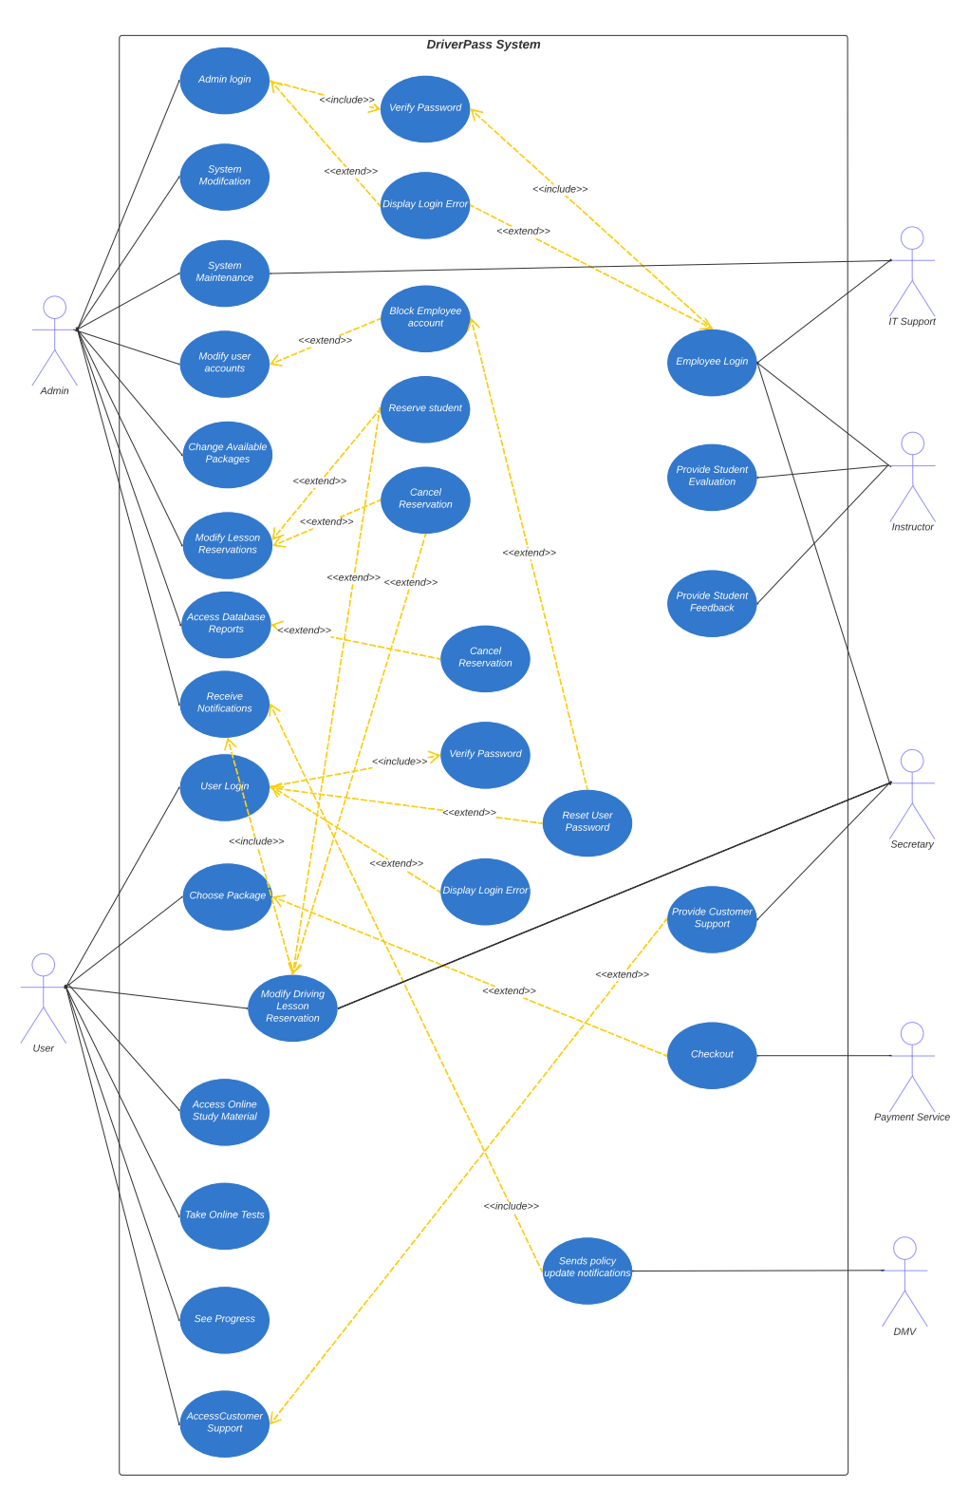

### UML Activity Diagrams

User Login and Password reset.

Purchasing Packages

Admin Data Download

### UML Sequence Diagram

*

## Technical Requirements

The system is required to be a web-based application and would need a cloud-based server infrastructure, such as AWS or Microsoft Azure, for hosting purposes. The cloud server infrastructure should be secure to layer and protect sensitive information such as customer data and payment information. This could include implementing SSL certificates for secure data transfer, setting up firewalls to prevent unauthorized access, and regularly backing up data to ensure that the data can be recovered in case of an unexpected outage. Additionally, choosing a cloud-based infrastructure that provides automatic scaling can help in ensuring the performance of the system upholds as users and the amount of data in the system increases.

The system would need a database management system, such as MySQL or MongoDB for storage and management as well as a web server, such as Apache, to handle HTTP requests. It would also need a selected programming language, such as Python or Java, for the implementation of the codebase of the system. It would need a payment gateway, such as Stripe or PayPal, to accept online payments from credit and debit cards. It would lastly need a content management system, such as WordPress, to provide the learning material to students.

It is important to consider the cost of the system. Approaches to reduce costs can include using open-source technologies and using technologies that provide efficiency. A backup and recovery option is also integral to the system.